
CS361 – Web Programming
Campus Events Hub
Individual Completed Work and Technical Solution
Student Name | Naje Alanazi
Student ID | S230011676
Assigned Role | Home Page, Shared Header/Footer, Navigation, and Page Integration
Project | Campus Events Hub
This file contains the completed implementation corresponding to the tasks assigned to this student in the submitted project records.
1. Assigned Tasks
2. Completed Solution
- Prepared a six-page sitemap covering Home, Events, Event Details, Registration, Registrations List, and About/Contact.
- Implemented reusable header and footer templates using PHP require_once so all pages share the same structure.
- Added dynamic active-navigation logic based on the current PHP filename.
- Built the Home page query to retrieve the nearest three future events, ordered by date and time.
- Displayed event images, categories, titles, dates, locations, and links while escaping dynamic output.
- Verified that Home, Events, Register, Registrations, and About/Contact navigation links route correctly.
3. Sitemap Prepared
Page | File | Purpose
Home | index.php | Introduction and next three upcoming events
Events | events.php | Complete list of events
Event Details | event.php?id=... | Selected-event information
Registration | register.php | Student registration form
Registrations List | registrations.php | Stored registrations table
About / Contact | about.php | Team details and contact form
4. Visual Evidence
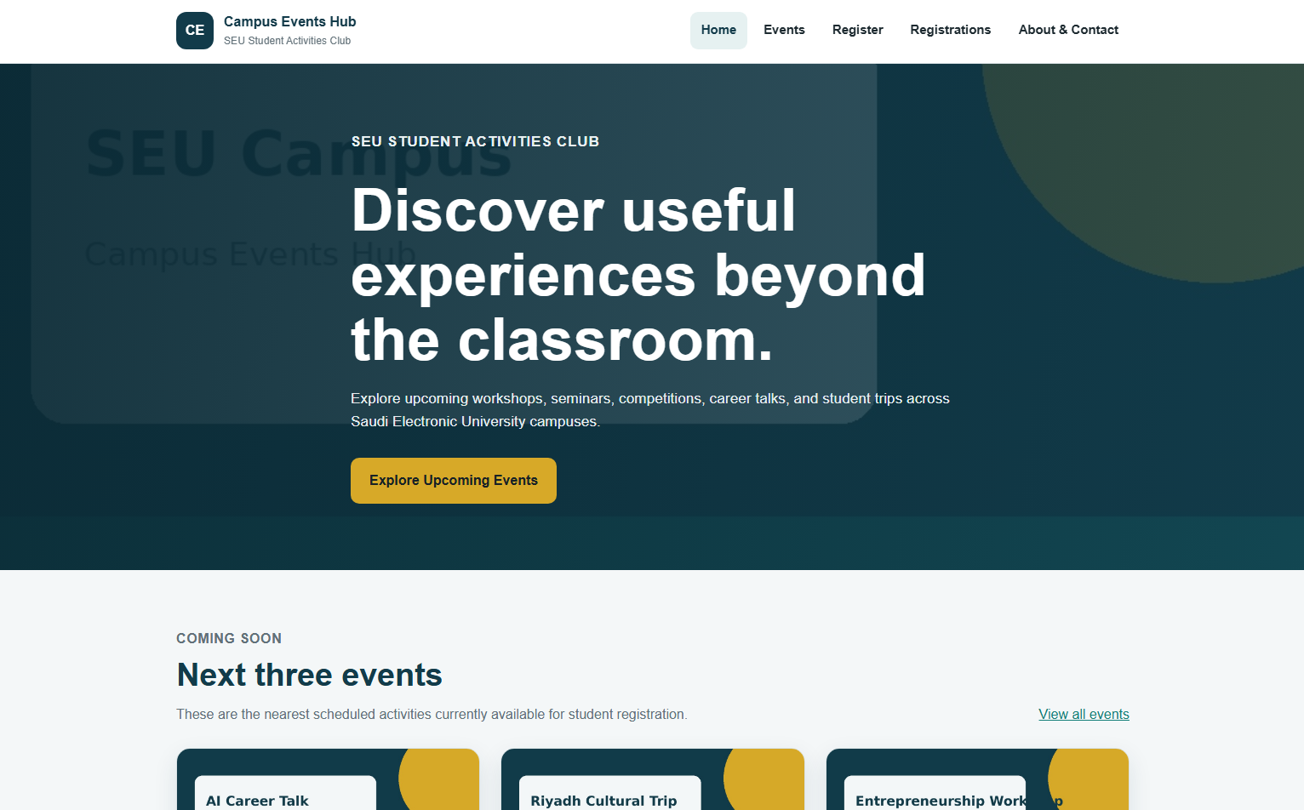
Completed Home page with shared navigation and the next three events.
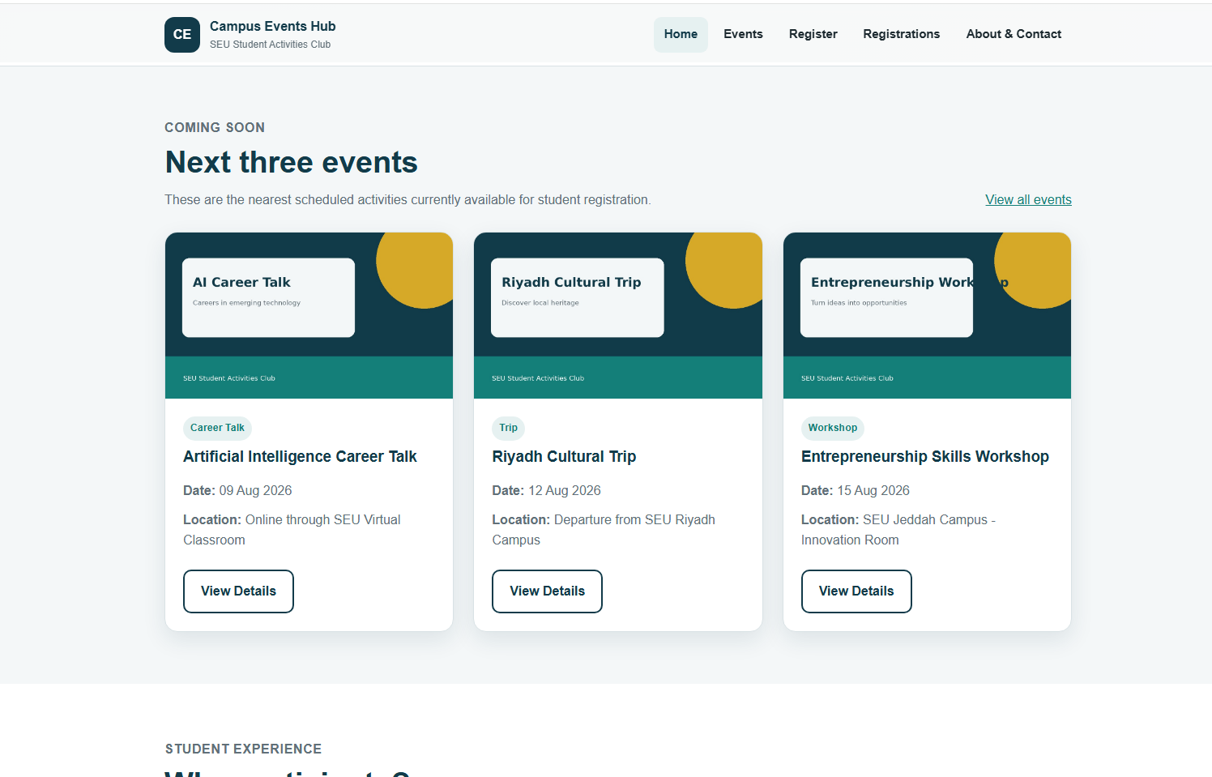
Dynamic upcoming-events section connected to the events data.
5. Verification Results
Test | Expected / Recorded Result | Status
Open index.php | The shared header, navigation, hero section, and footer appear. | Pass
Database contains upcoming events | Only the nearest three events are displayed in ascending date/time order. | Pass
Select View Details | The browser opens event.php with the correct numeric event ID. | Pass
Navigate between pages | The current menu item receives the active class. | Pass
No upcoming records | The Home page displays the defined empty-state message. | Pass

6. Relevant Source-Code Solution
The following code is taken from the submitted project source files and corresponds directly to the student's assigned implementation.
includes/header.php
<?php
if (!isset($pageTitle)) {
$pageTitle = 'Campus Events Hub';
}
$currentPage = basename($_SERVER['PHP_SELF']);
?>
<!DOCTYPE html>
<html lang="en">
<head>
<meta charset="UTF-8">
<meta name="viewport" content="width=device-width, initial-scale=1.0">
<meta name="description" content="SEU Student Activities Club events and student registration website">
<title><?php echo htmlspecialchars($pageTitle); ?> | Campus Events Hub</title>
<link rel="stylesheet" href="css/style.css">
</head>
<body>
<header class="site-header">
<div class="container nav-wrapper">
<a class="brand" href="index.php" aria-label="Campus Events Hub home page">
<span class="brand-mark">CE</span>
<span>
<strong>Campus Events Hub</strong>
<small>SEU Student Activities Club</small>
</span>
</a>
<nav class="main-nav" aria-label="Main navigation">
<ul>
<li><a class="<?php echo $currentPage === 'index.php' ? 'active' : ''; ?>" href="index.php">Home</a></li>
<li><a class="<?php echo in_array($currentPage, ['events.php', 'event.php']) ? 'active' : ''; ?>" href="events.php">Events</a></li>
<li><a class="<?php echo $currentPage === 'register.php' ? 'active' : ''; ?>" href="register.php">Register</a></li>
<li><a class="<?php echo $currentPage === 'registrations.php' ? 'active' : ''; ?>" href="registrations.php">Registrations</a></li>
<li><a class="<?php echo $currentPage === 'about.php' ? 'active' : ''; ?>" href="about.php">About & Contact</a></li>
</ul>
</nav>
</div>
</header>
<main>

includes/footer.php
</main>
<footer class="site-footer">
<div class="container footer-grid">
<div>
<h2>Campus Events Hub</h2>
<p>A university project for managing student activities and event registrations.</p>
</div>
<div>
<h2>Contact</h2>
<p>Email: activities@seu.edu.sa</p>
<p>Location: Saudi Electronic University, Riyadh</p>
</div>
</div>
<p class="copyright">&copy; 2026 SEU Student Activities Club. Academic project.</p>
</footer>
</body>
</html>

index.php
<?php
require_once 'includes/db.php';
$pageTitle = 'Home';
$sql = "SELECT * FROM events
WHERE event_date >= CURDATE()
ORDER BY event_date ASC, event_time ASC
LIMIT 3";
$upcomingEvents = mysqli_query($conn, $sql);
require_once 'includes/header.php';
?>
<section class="hero">
<div class="container hero-content">
<p class="eyebrow">SEU Student Activities Club</p>
<h1>Discover useful experiences beyond the classroom.</h1>
<p>Explore upcoming workshops, seminars, competitions, career talks, and student trips across Saudi Electronic University campuses.</p>
<a class="button button-accent" href="events.php">Explore Upcoming Events</a>
</div>
</section>
<section class="section">
<div class="container">
<div class="section-heading">
<div>
<p class="eyebrow">Coming Soon</p>
<h2>Next three events</h2>
<p>These are the nearest scheduled activities currently available for student registration.</p>
</div>
<a href="events.php">View all events</a>
</div>
<?php if ($upcomingEvents && mysqli_num_rows($upcomingEvents) > 0): ?>
<div class="event-grid">
<?php while ($event = mysqli_fetch_assoc($upcomingEvents)): ?>
<article class="event-card">
<img src="<?php echo htmlspecialchars($event['image']); ?>" alt="<?php echo htmlspecialchars($event['title']); ?>">
<div class="event-card-content">
<span class="badge"><?php echo htmlspecialchars($event['category']); ?></span>
<h3><?php echo htmlspecialchars($event['title']); ?></h3>
<ul class="meta-list">
<li><strong>Date:</strong> <?php echo date('d M Y', strtotime($event['event_date'])); ?></li>
<li><strong>Location:</strong> <?php echo htmlspecialchars($event['location']); ?></li>
</ul>
<a class="button button-outline" href="event.php?id=<?php echo (int) $event['id']; ?>">View Details</a>
</div>
</article>
<?php endwhile; ?>
</div>
<?php else: ?>
<div class="empty-state">
<h3>No upcoming events are available.</h3>
<p>Please check again later for new student activities.</p>
</div>
<?php endif; ?>
</div>
</section>
<section class="section section-white">
<div class="container">
<div class="section-heading">
<div>
<p class="eyebrow">Student Experience</p>
<h2>Why participate?</h2>
</div>
</div>
<div class="benefit-grid">
<article class="info-card">
<h3>Build practical skills</h3>
<p>Workshops and competitions provide chances to practise communication, technology, teamwork, and problem-solving.</p>
</article>
<article class="info-card">
<h3>Meet other students</h3>
<p>Campus activities create an easy way to connect with students from different programs and university branches.</p>
</article>
<article class="info-card">
<h3>Explore career paths</h3>
<p>Seminars and career talks introduce students to employers, emerging fields, and skills needed in the Saudi job market.</p>
</article>
</div>
</div>
</section>
<?php require_once 'includes/footer.php'; ?>

